(Approx. 512 words)

Kretchmar's Korner
The Russians are Coming
David Kretchmar, Hardware Technician
Sun City Summerlin Computer Club
https://www.scscc.club
dkretch ** gmail.com

As Russia's invasion of Ukraine grinds on, it becomes increasingly likely that Russia will intensify cyberattacks on perceived enemies, especially the United States. As a result, at least one major federal agency is no longer allowing employees to use any USB devices on their government computers. The ability to read/write optical media, CDs, and DVDs, has been completely cut off.

Ironically, the federal government is addressing the least likely avenue a cyber attacker is likely to use to install malware on their systems. The threat is most likely to manifest via an email containing a link to a site that will download a virus to an unsuspecting user's computer. The U.S. government does attach a warning to each email received outside the government domain. These warnings are unnecessary on your home computer, not because the threat is not real, but because ALL of the emails you receive comes from outside of your system. And it is almost certain this is the vector hackers will try to use to infect your system. Based on experience, I can safely predict that an infected email arriving in your Inbox will appear to be either from a trusted friend or a business entity with which you might have had some business.

Here is an example; this is an email I received recently:
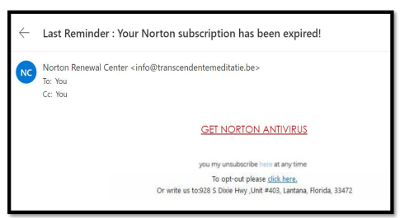

For at least 20 years, I have not run Norton Antivirus on any computer I have owned; this email was obviously a fake and most likely attempt to compromise my system. An obvious clue is the sending address: "info@transcendentalmediate.be." In addition to the not-very-professional sounding name, the sender is obviously based out of Belgium (.be is the internet country code top-level domain (ccTLD) for Belgium.) I happen to know that Norton is based in Mountain View, California. Another term for the activity represented by this type of email is phishing. Phishing is still the world's most common cyber threat. It is estimated three billion fraudulent emails are sent out every day in an attempt to compromise sensitive information. In 2022, according to CyberTalk.org, 30% of phishing email recipients clicked on the malicious link.

Here is another example, also from my Inbox:
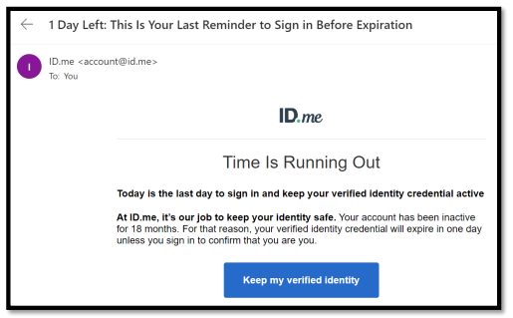
This was easy for me to spot since I do not use ID.me. However, this was a more sophisticated attempt since the ID.me sending address was spoofed. I could see this was not the actual sending address by hovering my mouse cursor over the address, NOT CLICKING.

You are most likely to be fooled by an email that appears to be sent from a trusted friend, as I was several years ago. My friend's computer had been compromised, and the virus perpetuated itself by invading my friend's contact list and sending infected emails to all his contacts. Be aware that the risk you will be exposed to malware infection is higher than it has ever been before. If you have any doubts about clicking on a link in any email message, don't do it.

